RDTI General Approval application template
Email: RDTIhelp@callaghaninnovation.govt.nz
Version 1.5
19.10.2022
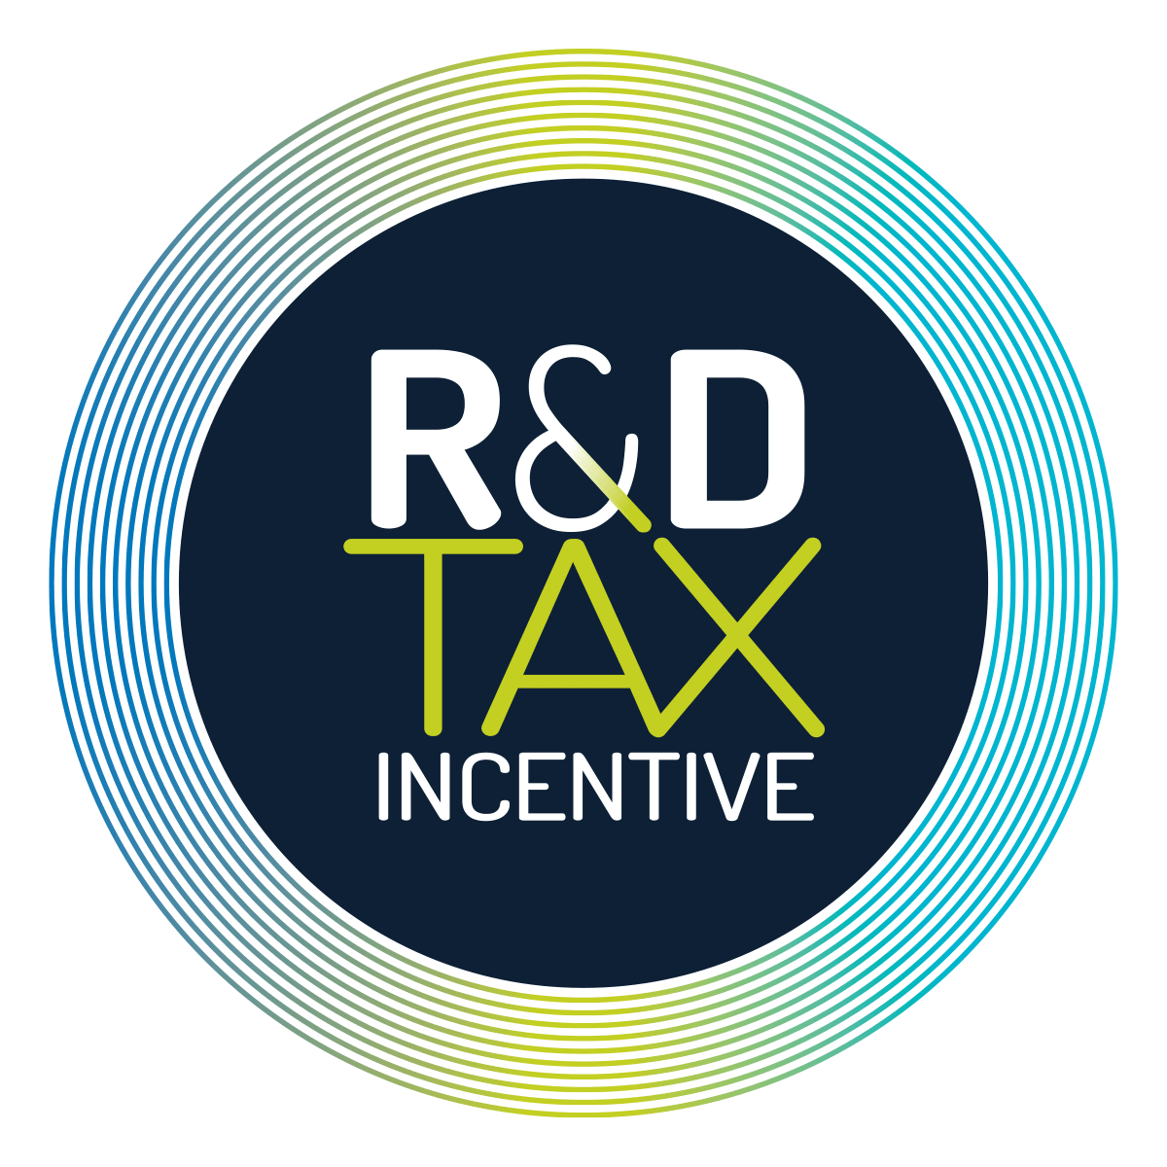

How to use this template
This template contains the actual questions from the RDTI General Approval* application form on the myIR portal, along with notes from Callaghan Innovation about the type and amount of information sought for key questions.
You can use the template to prepare your draft General Approval application. After you’ve completed your draft, we invite you to share it with us – we will be happy to review it and offer any feedback that we consider useful.
Once you’re happy with your application, you can cut and paste information from the draft into the relevant sections of the application on the myIR portal. You can also attach documents to the application that may assist when assessing your application.
Please do not submit or upload this draft application directly to Inland Revenue. RDTI applications must be submitted in the myIR portal.
* Most businesses access the RDTI via a General Approval application. There is a different application process if you want to become an RDTI Significant Performer – a business that intends to spend more than $2 million on eligible R&D in one income year. To find out more about applying to become a Significant Performer, Request Support from the RDTI Customer Engagement Team.

The basis of a successful application
To be approved, your application must demonstrate that your R&D project meets the key RDTI activity eligibility criteria, i.e. it:
- seeks to resolve scientific or technological uncertainty
- which cannot be resolved without a systematic approach
- seeks to create new knowledge, or new or improved processes, services or goods.
- Is not on the list of excluded R&D activities
The application asks you to list core R&D activities as well as any supporting R&D activities:
- Core R&D activities evaluate possible solutions to your scientific or technological uncertainty and have the purpose of creating new knowledge or new or improved services or goods. Core R&D activities must take place in New Zealand.
- Supporting activities are not Core R&D activities but support a Core R&D activity as their main or only purpose, and are required for and integral to the Core R&D activity (generally where there are Core activities, you will also have Supporting activities).
A General Approval application must list at least one Core activity – however, you may list several Core activities on the same application as part of an overarching R&D project. Although it’s not compulsory to list Supporting activities, we encourage you to do so as you are able to claim expenditure on these.
Please note that the online myIR portal enables you to record as many Core and Supporting activities as you like on your application. This template only has capacity for one Core activity and two Supporting activities, so if you have multiple activities please copy the relevant section/s of this template, until you have as many as you need.
If you do more than one R&D project in the same financial year, you can submit multiple General Approval applications.

You can upload supporting documents
Please note that you can support your application by uploading documents, including diagrams, in a wide range of formats.

How your application will be assessed
The application you submit to Inland Revenue will be assessed by an independent team of assessors based at Callaghan Innovation.
The team comprises specialised scientists, engineers and technologists, so it’s important to keep this audience in mind when writing your application, i.e. we encourage you to provide technical detail, where appropriate, in your application.
The assessors may contact you if they need further information or wish to clarify anything. In some cases, this may include a site visit, but can typically be resolved with a video call.
Once they’ve completed their assessment, the assessors will make a recommendation to Inland Revenue, who are responsible for deciding whether your application is approved.

Information you will need on hand when you complete this draft application
To complete this draft application, you will need the following information on hand:
- details of your R&D project/s
- details of the Core R&D activities and Supporting R&D activities you’re conducting as part of your project
- Australia New Zealand Standard Research Classification (ANZSRC) codes (information to help you locate the appropriate code is provided in this template)
- your estimated spend on eligible R&D activities.
Note that each party in a joint venture or partnership needs to enrol for RDTI and apply for General Approval, using the same project name and activity descriptions in their application.

Getting help to prepare your application
If you haven’t submitted a General Approval application before, we encourage you to Request Support before you start to prepare your application.
Callaghan Innovation have Customer Engagement Specialists who can meet with you to explain any aspect of the RDTI, and talk you through the application process. We can support you to understand how R&D is defined according to the relevant legislation (the Income Tax Act 2007 and the Tax Administration Act 1994) and how this may apply to your business and industry. We'll discuss the key activity eligibility criteria, the concept of Core R&D activities and Supporting R&D activities and the type of information that may be needed when explaining these activities.
Note: Any discussion with a Customer Engagement Specialist will not be binding. The final decision on your application will be based on the recommendation of an independent assessor at Callaghan Innovation, following due consideration of eligibility criteria set out in legislation.

General Approval Application Form

RDTI Customer

Project Details
Note: A “project” is generally a group of related Core R&D activities and Supporting R&D activities. If your R&D does not fall under the concept of a project, you could create a project for each Core R&D activity you are requesting approval for.

Your General Approval Application can be approved for a period of up to three income years. If your project is longer than this, you can put in another General Approval in the future for that phase of the work.

Project Identifier
Name your project:
[110 characters max]
Describe the overall objective of your project:
[There is a limit in the myIR portal for this section of 1000 characters. Other sections have a limit of 20000 characters]

Project Spending
Note: At the application stage, you are asked to give an estimate of your spending, then you specify your exact spending when you submit your Supplementary Return. Your estimate will not affect the outcome of your application. However, if there’s a significant difference between your estimate and actual spending, you may be asked to confirm that any additional activities and expenditure are eligible. It’s recommended you contact Inland Revenue before submitting your Supplementary Return if your actual spending looks like it will exceed your estimate.
What is your estimated spend on eligible R&D activities for this project? [for the timeframe of this General Approval]
$

Have you received any government funding for your R&D? [If “yes” provide details about the source of the funding and which projects it was used for]

Yes | No

Project Length
Enter the start date of the project (even if it hasn’t begun yet):
Enter the anticipated end date of the project:

ANZSRC Codes
ANZSRC applies to your research activity. This is not your BIC code.
Note: On the online application, you need to include the Australian and New Zealand Standard Research Classification (ANZSRC) code most relevant to your area of research.

ANZSRC is a statistical classification used for R&D measurement and analysis. It is for statistical purposes only and will not be used during the appraisal process.

Please note that the link on the online application to help locate relevant ANZSRC codes is currently not working. To help you complete this part of the application, please choose from the full list of ANZSRC codes here.
Enter code here

Project Owner Details
This should be the best contact for any technical questions during the assessment stage.
First name:
Last name:
Role:
Contact phone country:
Contact phone type:
Phone:
Email:

Core R&D Activities
Answer this set of questions for each activity
Note: Core R&D activities are those which have a material purpose of evaluating possible solutions to your scientific or technological uncertainty and creating new knowledge, or new or improved processes, services or goods. Approval may be granted for up to three years.
Remember to describe your Core R&D activities from a technological or scientific perspective. We request that you don’t provide a business case or address factors such as the prospect of commercial success associated with your project, as these are not relevant to the RDTI.

For more information, in the RDTI Guidance (IR1240) page 33 to 35 describes example situations in which scientific or technological uncertainty may arise.

There are some activities that are excluded. We recommend referring to the section “Activities excluded from being a research and development (R&D) activity” in the RDTI Guidance (IR1240) pages 51 to 62 before you start. Please be aware that some activities are excluded from being Core R&D activities but are eligible as supporting activities. A good example is Clause 20 which affects software development. In other cases an activity may be excluded from being both Core and Supporting R&D activities.

Core R&D Activity (Copy section if more Core R&D activities are required)
Name:
Activity starts this tax year: [Show what income year the activity begins in, e.g. 31 March 2023 for FY23]
Activity ends this tax year: [Show what income year the activity ends in]
Describe your Core R&D activity: [Suggested maximum length - 150 words]

Describe the scientific or technological uncertainty that your Core R&D activity has a material purpose of resolving:
Note:
In expressing the scientific or technological uncertainty it is often helpful to cover:
- The overall problem
- The main challenges you need to overcome to solve the problem
- Why are these challenging? You should be demonstrating the bit of knowledge you need to gain to solve your challenges isn’t available ‘off the shelf’. Consider;
  - whether knowledge to resolve the uncertainty already exists, and if so, whether you’re able to access it in any way.
  - whether a person with relevant knowledge in the field has considered the uncertainty and concluded that it can be resolved without a systematic course of investigation.
- The technical constraints and/or performance targets compared to pre-existing capability is often helpful in crystallising the expression of uncertainty.

Please ensure your answers are specific and you provide appropriate examples and evidence where needed. You can include hyperlinks in your answers and attach documents/diagrams.

We request you do not simply express an uncertainty as “how to design ..”. A core activity generally starts with some testable idea or proposition (hypothesis). RDTI (IR1240) page 34 shows examples of situations where uncertainty may exist. For example it may exist in architectures, algorithms, patterns or systems for resolving challenges created through constraints.
Draft your answer here: [Suggested maximum length - 500 words]

Describe the systematic approach you took to conducting the Core R&D activity
Note:
Work is considered to have a systematic approach if it is sufficiently planned and structured to test possible solution(s) and generate valid results. The systematic approach described should be that part which is focussed on and required for solving the scientific or technological uncertainty you have stated.
The text of the systematic approach should
- describe the possible solution(s) you are considering.
- describe the actual activities planned or undertaken to resolve the uncertainty. For a multi-year application, the expectation is the application should describe proposed activities across the whole period of the application. This is to show progression justifying the multi-year approval.
- describe any experiments that are planned or were performed to gain scientific or engineering knowledge
- describe the results of tests you may have undertaken.
- describe what has been learnt or what may be learnt from your core activity.

Note. Expressing a development methodology such as ‘agile’ does not answer the systematic approach.
Please ensure your answers are specific and you provide appropriate examples and evidence where needed. You can include hyperlinks in your answers and attach documents/diagrams.
Draft your answer here: [Suggested maximum length - 250 words]

Describe how your Core R&D activity intends to create either:
- New knowledge
- New or improved processes, services or goods
Note: This question is about identifying what is new about the proposed solution to your scientific/technological uncertainty, i.e. what is the new knowledge or new or improved product or service or process.

Examples include but are not limited to, new algorithms, new results, new or improved processes or software services, new or improved physical products.

When answering it, it may help if you think ”how do I know that the solution is new?”
Note that it is not a requirement that your R&D actually succeeds in achieving its purpose or is commercially viable. Unsuccessful R&D can still qualify for the RDTI.

Please ensure your answers are specific and you provide appropriate examples and evidence where needed. You can include hyperlinks in your answers and attach documents/diagrams.
Draft your answer here: [Suggested maximum length - 200 words]

Supporting R&D Activities
Answer this set of questions for each Supporting R&D activity.
Do you have any Supporting R&D activities for this project?
Yes | No

Supporting R&D Activity (1)
Note: The definition of a Supporting activity is one that is performed in support of the Core R&D activities in your application, but doesn’t meet the criteria of Core R&D activity in and of itself.

You can add multiple Supporting R&D activities.

To be eligible, a Supporting R&D activity must:
- support the Core R&D activity as its only or main purpose, and
- be required for, and integral to, the Core R&D activity
- Not be listed as an excluded activity
- one supporting R&D activity can be connected to one or more Core R&D activities.

Note that Supporting R&D activities can be performed before, during or after a Core R&D activity. However, if you perform a Supporting activity before you start a Core R&D activity, and don't end up doing the Core R&D activity, you can't claim the credit for your Supporting R&D activity.

Each supporting R&D activity can be connected to one or more Core R&D activities.

Name your Supporting R&D activity here: [You must have a unique name for each]
Activity starts this tax year: [Show what income year the activity begins in]
Activity ends this tax year: [Show what income year the activity ends in]

Describe your Supporting R&D activity:
Note: The RDTI Guidance (IR1240) page 38 lists a set of activities that may be classed as supporting R&D activities. The list is not exhaustive, however we recommend viewing this list to understand examples of supporting R&D activities.

[Draft your answer here: Suggested maximum length - 250 words]
Describe how this satisfies the Supporting R&D activity definition (above):
[Draft your answer here: Suggested maximum length - 250 words]

Supporting R&D Activity (2) (Copy this section of the template, if more Supporting activities are required)
Name your Supporting R&D activity here: [You must have a unique name for each]

Activity starts this tax year: [Show what income year the activity begins in]
Activity ends this tax year: [Show what income year the activity ends in]
Describe your Supporting R&D activity:
[Draft your answer here: Suggested maximum length - 250 words]
Describe how this satisfies the Supporting R&D activity definition (above):
Draft your answer here: [Suggested maximum length - 250 words]

Congratulations - you’ve completed the main parts of your draft application. Note that the online application asks you some further questions not included on this template, such as whether you’re involved in a joint venture or partnership.
Remember, our team of Customer Engagement Specialists can review your draft application before you submit it. We recommend you take advantage of this free service, especially if you’re applying for the first time. And don’t forget that you can support your application by uploading other documents, such as diagrams, in a wide range of formats.

